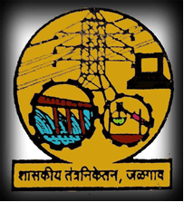

**Government Polytechnic Jalgaon**

Academic Year 2019-20

Course Code

Linear Integrated Circuit

(22423)

EJ 4 I.

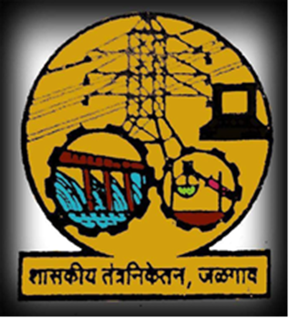

**Government Polytechnic Jalgaon**

Academic Year 2019-20

Course Code

Consumer Electronics

(22425)

EJ 4 I.

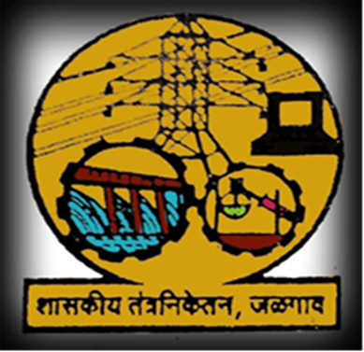

**Government Polytechnic Jalgaon**

Academic Year 2019-20

Course Code

Microcontroller And Applications

(22426)

EJ 4 I.

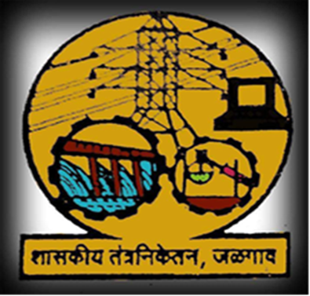

**Government Polytechnic Jalgaon**

Academic Year 2019-20

Course Code

Basic Power Electronics

(22427)

EJ 4 I.

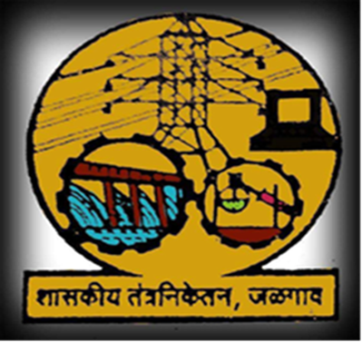

**Government Polytechnic Jalgaon**

Academic Year 2019-20

Course Code

Digital Communication System

(22428)

EJ 4 I



**Government Polytechnic Jalgaon**

Academic Year 2019-20

Course Code

Maintenance Of Electronics Equipment And EDA Tools Practices

(22036)

EJ 4 I